UNIT-IV
OOPS
Constant data member:-
C++ programming language. It is the const keywords used to define the constant value that cannot change during program execution. It means once we declare a variable as the constant in a program, the variable's value will be fixed and never be changed. If we try to change the value of the const type variable, it shows an error message in the program.
It is a const variable used to define the variable values that never be changed during the execution of a program. And if we try to modify the value, it throws an error.
#include <iostream>
#include <conio.h>
using namespace std;
int main ()
{
// declare the value of the const
const int num = 25;
num = num + 10;
return 0;
}

Const member functions in C++:-

Constant member functions are those functions that are denied permission to change the values of the data members of their class. To make a member function constant, the keyword const is appended to the function prototype and also to the function definition header.
Like member functions and member function arguments, the objects of a class can also be declared as const. An object declared as const cannot be modified and hence, can invoke only const member functions as these functions ensure not to modify the object. A const object can be created by prefixing the const keyword to the object declaration. Any attempt to change the data member of const objects results in a compile-time error.
The const member functions are the functions which are declared as constant in the program. The object called by these functions cannot be modified. It is recommended to use const keyword so that accidental changes to object are avoided.
A const member function can be called by any type of object. Non-const functions can be called by non-const objects only.

Important Points
- When a function is declared as const, it can be called on any type of object, const object as well as non-const objects.
- Whenever an object is declared as const, it needs to be initialized at the time of declaration. however, the object initialization while declaring is possible only with the help of constructors.
- A function becomes const when the const keyword is used in the function’s declaration. The idea of const functions is not to allow them to modify the object on which they are called.
- It is recommended practice to make as many functions const as possible so that accidental changes to objects are avoided.

#include <iostream>
using namespace std;

class Demo {
int x;

public:
void set_data(int a) { x = a; }

// constant member function
int get_data() const
{
// Error while attempting to modify the data
// member
++x;
return x;
}
};

main()
{
Demo d;
d.set_data(10);
cout << endl << d.get_data();

return 0;
}

Static Data Members
Static data members are class members that are declared using static keywords. A static member has certain special characteristics which are as follows:
- Only one copy of that member is created for the entire class and is shared by all the objects of that class, no matter how many objects are created.
- It is initialized before any object of this class is created, even before the main starts outside the class itself.
- It is visible can be controlled with the class access specifiers.
- Its lifetime is the entire program.
// C++ Program to demonstrate the use of
// static data members
#include <iostream>
using namespace std;

// class definition
class A {
public:
// static data member here
static int x;
A() { cout << "A's constructor called " << endl; }
};

// we cannot initialize the static data member inside the
// class due to class rules and the fact that we cannot
// assign it a value using constructor
int A::x = 2;

// Driver code
int main()
{
// accessing the static data member using scope
// resultion operator
cout << "Accessing static data member: " << A::x
<< endl;

return 0;
}

Static Member Function
The static keyword is used with a variable to make the memory of the variable static once a static variable is declared its memory can’t be changed. To know more about static keywords refer to the article static Keyword in C++.
Static members of a class are not associated with the objects of the class. Just like a static variable once declared is allocated with memory that can’t be changed every object points to the same memory. To know more about the topic refer to a static Member in C++.
// C++ Program to show the working of
// static member functions
#include <iostream>
using namespace std;

class Box
{
private:
static int length;
static int breadth;
static int height;

public:

static void print()
{
cout << "The value of the length is: " << length << endl;
cout << "The value of the breadth is: " << breadth << endl;
cout << "The value of the height is: " << height << endl;
}
};

// initialize the static data members

int Box :: length = 10;
int Box :: breadth = 20;
int Box :: height = 30;

// Driver Code

int main()
{

Box b;

cout << "Static member function is called through Object name: \n" << endl;
b.print();

cout << "\nStatic member function is called through Class name: \n" << endl;
Box::print();

return 0;
}

Static Member Function in C++
Static Member Function in a class is the function that is declared as static because of which function attains certain properties as defined below:
- A static member function is independent of any object of the class.
- A static member function can be called even if no objects of the class exist.
- A static member function can also be accessed using the class name through the scope resolution operator.
- A static member function can access static data members and static member functions inside or outside of the class.
- Static member functions have a scope inside the class and cannot access the current object pointer.
- You can also use a static member function to determine how many objects of the class have been created.

The reason we need Static member function:
- Static members are frequently used to store information that is shared by all objects in a class.
- For instance, you may keep track of the quantity of newly generated objects of a specific class type using a static data member as a counter. This static data member can be increased each time an object is generated to keep track of the overall number of objects.

Polymorphism
The word “polymorphism” means having many forms. In simple words, we can define polymorphism as the ability of a message to be displayed in more than one form. A real-life example of polymorphism is a person who at the same time can have different characteristics. A man at the same time is a father, a husband, and an employee. So the same person exhibits different behavior in different situations. This is called polymorphism. Polymorphism is considered one of the important features of Object-Oriented Programming.

Types of Polymorphism
- Compile-time Polymorphism
- Runtime Polymorphism
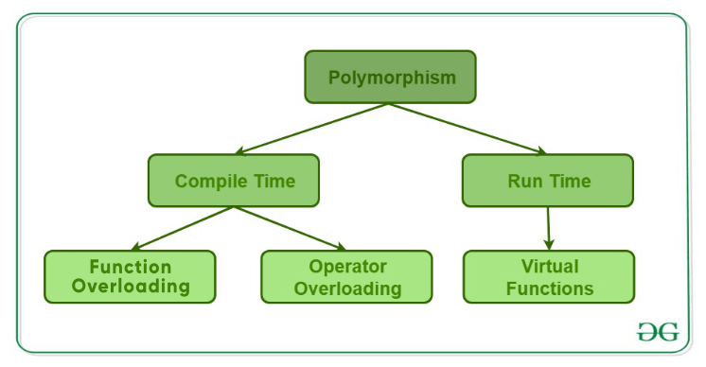

1. Compile-Time Polymorphism
This type of polymorphism is achieved by function overloading or operator overloading.

A. Function Overloading
When there are multiple functions with the same name but different parameters, then the functions are said to be overloaded, hence this is known as Function Overloading. Functions can be overloaded by changing the number of arguments or/and changing the type of arguments. In simple terms, it is a feature of object-oriented programming providing many functions that have the same name but distinct parameters when numerous tasks are listed under one function name. There are certain Rules of Function Overloading that should be followed while overloading a function.
// C++ program to demonstrate
// function overloading or
// Compile-time Polymorphism
#include <bits/stdc++.h>

using namespace std;
class Geeks {
public:
// Function with 1 int parameter
void func(int x)
{
cout << "value of x is " << x << endl;
}

// Function with same name but
// 1 double parameter
void func(double x)
{
cout << "value of x is " << x << endl;
}

// Function with same name and
// 2 int parameters
void func(int x, int y)
{
cout << "value of x and y is " << x << ", " << y
<< endl;
}
};

// Driver code
int main()
{
Geeks obj1;

// Function being called depends
// on the parameters passed
// func() is called with int value
obj1.func(7);

// func() is called with double value
obj1.func(9.132);

// func() is called with 2 int values
obj1.func(85, 64);
return 0;
}

B. Operator Overloading

Operator overloading is a compile-time polymorphism. It is an idea of giving special meaning to an existing operator in C++ without changing its original meaning
C++ has the ability to provide the operators with a special meaning for a data type, this ability is known as operator overloading. For example, we can make use of the addition operator (+) for string class to concatenate two strings. We know that the task of this operator is to add two operands. So a single operator ‘+’, when placed between integer operands, adds them and when placed between string operands, concatenates them.
// C++ program to demonstrate
// Operator Overloading or
// Compile-Time Polymorphism
#include <iostream>
using namespace std;

class Complex {
private:
int real, imag;

public:
Complex(int r = 0, int i = 0)
{
real = r;
imag = i;
}

// This is automatically called
// when '+' is used with between
// two Complex objects
Complex operator+(Complex const& obj)
{
Complex res;
res.real = real + obj.real;
res.imag = imag + obj.imag;
return res;
}
void print() { cout << real << " + i" << imag << endl; }
};

// Driver code
int main()
{
Complex c1(10, 5), c2(2, 4);

// An example call to "operator+"
Complex c3 = c1 + c2;
c3.print();
}

2. Runtime Polymorphism
This type of polymorphism is achieved by Function Overriding. Late binding and dynamic polymorphism are other names for runtime polymorphism. The function call is resolved at runtime in runtime polymorphism. In contrast, with compile time polymorphism, the compiler determines which function call to bind to the object after deducing it at runtime.

A. Function Overriding
Function Overriding occurs when a derived class has a definition for one of the member functions of the base class. That base function is said to be overridden.
// C++ program for function overriding with data members
#include <bits/stdc++.h>
using namespace std;

// base class declaration.
class Animal {
public:
string color = "Black";
};

// inheriting Animal class.
class Dog : public Animal {
public:
string color = "Grey";
};

// Driver code
int main(void)
{
Animal d = Dog(); // accessing the field by reference
// variable which refers to derived
cout << d.color;
}

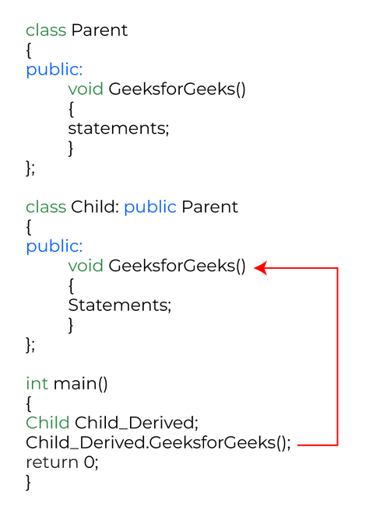

B. Virtual Function
A virtual function is a member function that is declared in the base class using the keyword virtual and is re-defined (Overridden) in the derived class.

Some Key Points About Virtual Functions:
- Virtual functions are Dynamic in nature.
- They are defined by inserting the keyword “virtual” inside a base class and are always declared with a base class and overridden in a child class
- A virtual function is called during Runtime

// C++ Program to demonstrate
// the Virtual Function
#include <iostream>
using namespace std;

// Declaring a Base class
class GFG_Base {

public:
// virtual function
virtual void display()
{
cout << "Called virtual Base Class function"
<< "\n\n";
}

void print()
{
cout << "Called GFG_Base print function"
<< "\n\n";
}
};

// Declaring a Child Class
class GFG_Child : public GFG_Base {

public:
void display()
{
cout << "Called GFG_Child Display Function"
<< "\n\n";
}

void print()
{
cout << "Called GFG_Child print Function"
<< "\n\n";
}
};

int main()
{
// Create a reference of class GFG_Base
GFG_Base* base;

GFG_Child child;

base = &child;

// This will call the virtual function
base->display();

// This will call the non-virtual function
base->print();
}

Virtual Function
A virtual function (also known as virtual methods) is a member function that is declared within a base class and is re-defined (overridden) by a derived class. When you refer to a derived class object using a pointer or a reference to the base class, you can call a virtual function for that object and execute the derived class’s version of the method.
- Virtual functions ensure that the correct function is called for an object, regardless of the type of reference (or pointer) used for the function call.
- They are mainly used to achieve Runtime polymorphism.
- Functions are declared with a virtual keyword in a base class.
- The resolving of a function call is done at runtime.

Rules for Virtual Functions
The rules for the virtual functions in C++ are as follows:
- Virtual functions cannot be static.
- A virtual function can be a friend function of another class.
- Virtual functions should be accessed using a pointer or reference of base class type to achieve runtime polymorphism.
- The prototype of virtual functions should be the same in the base as well as the derived class.
- They are always defined in the base class and overridden in a derived class. It is not mandatory for the derived class to override (or re-define the virtual function), in that case, the base class version of the function is used.
- A class may have a virtual destructor but it cannot have a virtual constructor.
// C++ program to illustrate
// concept of Virtual Functions

#include <iostream>
using namespace std;

class base {
public:
virtual void print() { cout << "print base class\n"; }

void show() { cout << "show base class\n"; }
};

class derived : public base {
public:
void print() { cout << "print derived class\n"; }

void show() { cout << "show derived class\n"; }
};

int main()
{
base* bptr;
derived d;
bptr = &d;

// Virtual function, binded at runtime
bptr->print();

// Non-virtual function, binded at compile time
bptr->show();

return 0;
}

